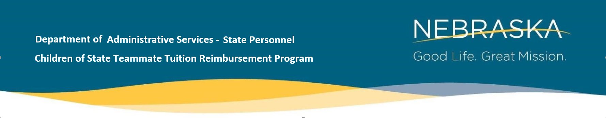
Reimbursement Request Form
Submit to: as.employeebenefits@nebraska.gov
Teammate:
_________________________ __________ _______________________________
First Name MI Last Name
______________ __________________________________________
Employee ID Work Email
Child of Teammate:
__________________________ ________ ______________________________
First Name MI Last Name
Date of Birth: _______________ Student ID# _________________ Term___________
- My child is not currently enrolled in or attending high school.

Reimbursement Document(s) Submitted to Display:
- Paid Account Activity Summary showing tuition breakdown by type of cost
- Validation of approved program/Degree Audit
- Validation of Pass or ‘C’ or better grade. Final Grade report
- Submitted within 30 days of end of term
For DAS State Personnel Office Use Only:

Received ___/___/____ Reimbursement Eligible? Y / N Amount:
Teammate Verification of Employment: Y / N
Processed by _____________________________________________ Date ___/___/____
Co777-mments:7

Revised 2/2023

