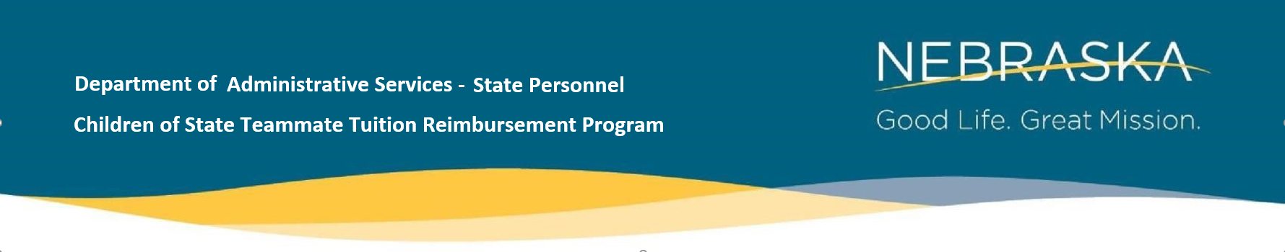
Eligibility Verification Request Form
Submit to: as.employeebenefits@nebraska.gov
Teammate:
__________________________ ________ _______________________________
First Name MI Last Name
________________ ____________________ ________________________________
Employee ID Agency Work Email
Child of Teammate:
__________________________ ________ _______________________________
First Name MI Last Name
Legal Relationship to Teammate ____________ Date of Birth __________________
- My child is not currently enrolled in or attending high school.

Community College Student ID number __________________
Community College(s): and campus
- Western Nebraska CC ______________
- Mid-Plains CC ______________
- Northeast CC ______________

- Central CC _______________
- Southeast CC _______________
- Metro CC _______________

Supporting Document(s) Submitted:
- Birth Certificate
- Adoption Records
- Other _________________________________________________________________________
For DAS State Personnel Office Use Only:
Received ___/___/____ Eligible? Y / N
Processed by _____________________________________________ Date ___/___/____
Comments:

Revised 02/2023

